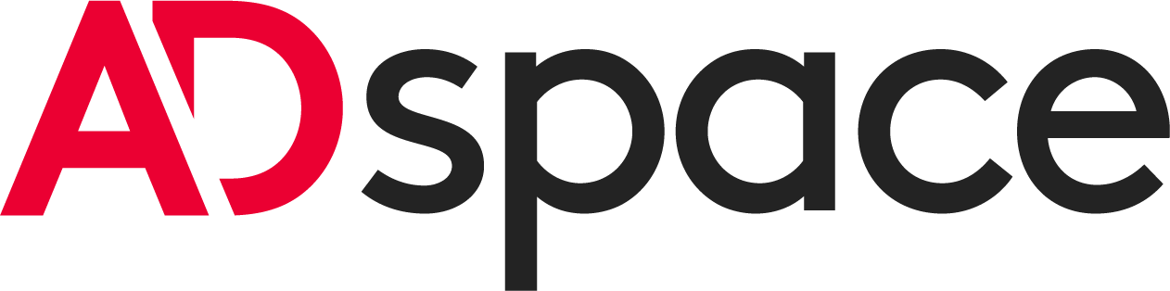
Request access code campaigns on
Administrator account

To be completed and signed by the Administrator:

I, THE UNDERSIGNED, …………………………………………… Position: ……………………………………,

I hereby certify that I have been duly authorized as an Administrator and have the ability, under my sole responsibility and at my sole discretion, to create User accounts and determine their access rights within ADspace (as defined in the ADspace Terms of Use) on behalf of the following company:

Company name:
Form and social capital: …………………………………………………………………………………………………..……….
SIREN:
Adress: ……………………………………………………………………………………………………………………………

ADMINISTRATOR NAME | FIRST NAME | E-MAIL | PHONE NUMBER

I declare that I have read the Commercial Terms and Conditions, the General Terms and Conditions of Sale of France Télévisions Publicité, as well as the General Terms of Use of Adspace (all accessible on the website http://www.francetvpub.fr) and expressly accept their provisions.

Established at…………………………, on……………,

Signature:

The information collected in this form will be used by France Télévisions Publicité to allow you to use the ADspace service. For more information, please consult our Third-Party Privacy Policy accessible at the following address:

https://www.francetvpub.fr/wp-content/uploads/2020/12/politique-de-confidentialite%CC%81-tiers1.pdf

